**ASSIGNMENT – I**

**DOMAIN:-IOT**

**TOPIC:-SMART HOME**

**NAME:-SOWMIYA N**

**REGISTER NUMBER:-211519106152**

**COLLEGE:-PANIMALAR INSTITUTE 0F TECHNOLOGY  
TOPIC: HOME AUTOMATION SYSTEM**

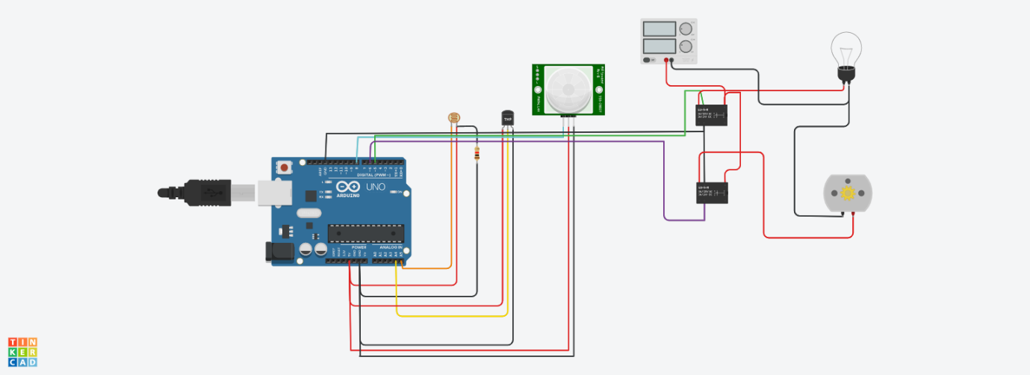

CODE

float x,y,z,temp;

void setup()

{

pinMode(8, INPUT);

pinMode (5, OUTPUT);

pinMode (6, OUTPUT);

pinMode (A5, INPUT);

pinMode (A4, INPUT);

Serial.begin(9600);

}

void loop()

{

x=digitalRead(8);

y=analogRead(A5);

z=analogRead (A4);

Serial.println(x);

Serial.println(y);

Serial.println(z);

temp = (double)z/1024;

temp = temp * 5;

temp = temp - 0.5;

temp = temp * 100;

if( (x>0) )

{

if ((y<550)&&(temp>30))

{

digitalWrite(5, HIGH);

digitalWrite(6, HIGH);

}

else if((y<550)&&(temp<30))

{

digitalWrite(5, HIGH);

digitalWrite(6, LOW);

}

else if((y>550)&&(temp>30))

{

digitalWrite(5, LOW);

digitalWrite(6, HIGH);

}

else if((y>550)&&(temp<30))

{

digitalWrite(5, LOW);

digitalWrite(6, LOW);

}

}

else

{

digitalWrite(5, LOW);

digitalWrite(6, LOW);

}

}

**LINK:- https://www.tinkercad.com/things/cwgeXdGxWFT-brilliant-albar-hango/editel?tenant=circuits**